to Kutni_isjecak :d :n
;cs Kutni_isjecak 100 8
repeat :n[ make "p pos Make "H heading
lt 360/:n/2 fd :d make "P1 pos bk :d rt 360/:n/2 rt 360/:n/2 fd :d make "P2 pos bk :d lt 360/:n/2
pu setpos :P1 pd
make "b (distance :p2)/2 ;računanje udaljenosti između dvije točke (promjer velike osi elipse)
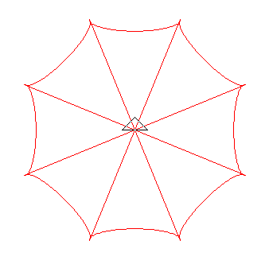
ELLIPSEARC2 -180 :b/4 :b 0 ;crtanje poluosi elipse - okrenute na gore
setpos :p setheading :H rt 360/:n]
end

to kisobran1 :n :D
;cs kisobran1 8 150
make "L []
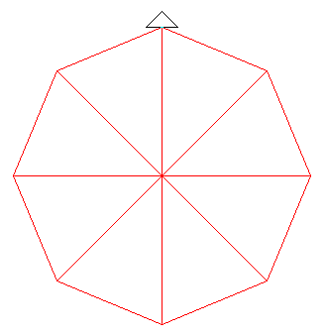
repeat :n[fd :d make "L lput pos :L bk :d rt 360/:n]
show :L
setpos first :l
for [i 1 [count :L]][ setpos Item :i :l]
make "r1 distance first :L
pr :r1 setpos first :l
end

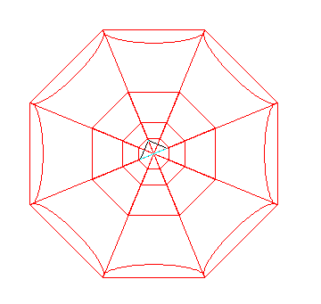
to kisobran :d :n
;cs kisobran 100 8
cs Kutni_isjecak :d :n
lt 360/:n/2 kisobran1 :n :D bk :d
kisobran1 :n :D/2 bk :d/2
kisobran1 :n :D/4 bk :d/4
kisobran1 :n :D/8 bk :d/8
end

